***Claudia Nerea Borrachero Mallofret***

EXAMEN BASE DE DATOS (SQL)

1. select pl.productLine,count(p.productName) from productlines pl inner join products p on p.productLine=pl.productLine group by pl.productLine;

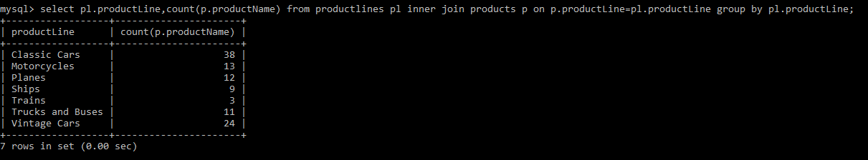

1. select o.officeCode, o.city from offices o inner join employees e on o.officeCode=e.officeCode where(select count(e.firstName) from employees e) group by o.city order by o.officeCode desc limit 1;

SELECT O.OFFICECODE,O.CITY, COUNT(*) AS EMP_NO FROM EMPLOYEES E INNER JOIN OFFICES O ON E.OFFICECODE=E.OFFICECODE GROUP BY O.OFFICECODE ORDER BY COUNT(*) DESC LIMIT 1;

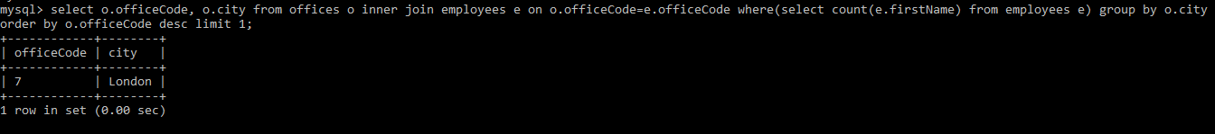

1. select c.customerName,p.amount from customers c inner join payments p on c.customerNumber=p.customerNumber where p.amount>100000;

SELECT C.CUSTOMERNAME,TRUNCATE(SUM(P.AMOUNT)) FROM CUSTOMERS C INNER JOIN PAYMENTS P ON C.CUSTOMERNUMBER=P.CUSTOMERNUMBER GROUP BY C.CUSTOMERNAME HAVING SUM(P.AMOUNT)>100000;

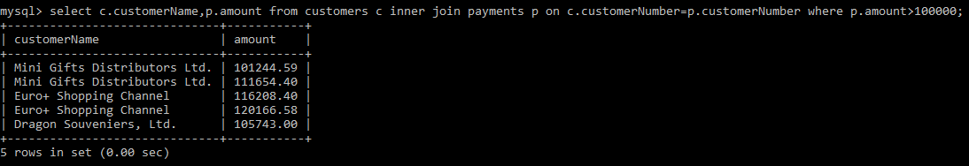

1. select o.priceEach,p.productName,(p.buyPrice-o.priceEach) as 'Diferencia' from orderdetails o inner join products p on o.productCode=p.productCode order by o.priceEach asc limit 1; 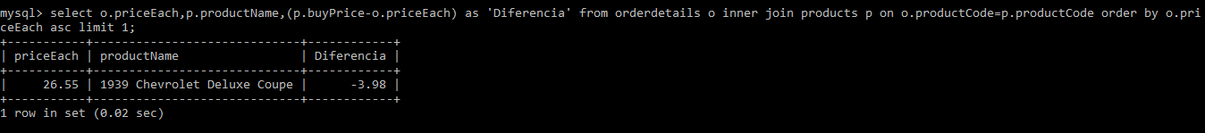
2. select c.customerName,e.firstName from customers c inner join employees e on c.salesRepEmployeeNumber=e.employeeNumber;

SELECT C.CUSTOMERNAME,C.CONTACTLASTNAME FROM CUSTOMERS C LEFT JOIN EMPLOYEES E ON C.SALESREPEMPLOYEENUMBER=E.EMPLOYEENUMBER;

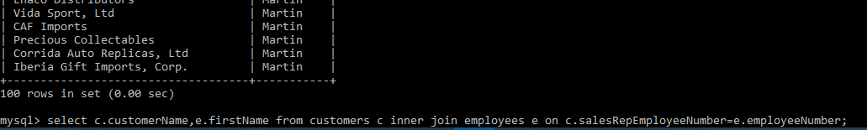

1. select * from orders o inner join customers c on o.customerNumber=c.customerNumber inner join employees e on c.salesRepEmployeeNumber=e.employeeNumber inner join offices ofi on e.officeCode=ofi.officeCode where ofi.city='San Francisco';
2. select (od.priceEach*od.quantityOrdered) as 'Total' from orderdetails od inner join orders o on od.orderNumber=o.orderNumber where YEAR(o.orderDate)=2003;

SELECT CONCAT(SUM(OD.PRICEEACH*OD.QUANTITYORDERED),’$’) AS 'TOTAL' FROM ORDERDETAILS OD INNER JOIN ORDERS O ON OD.ORDERNUMBER=O.ORDERNUMBER WHERE YEAR(O.ORDERDATE)=2003 GROUP BY O.ORDERNUMBER;



1. select (sum(o.orderNumber)) as 'Total_Pedidos',MONTHNAME(o.orderDate) from orders o where YEAR(o.orderDate) between 2003 and 2005 and MONTHNAME(o.orderDate)in ('September','October','November','December') group by MONTHNAME(o.orderDate) order by MONTHNAME(o.orderDate);

WHERE O.ORDERDATE BETWEEN ‘2003-09-01’ AND ‘2005-12-31’;

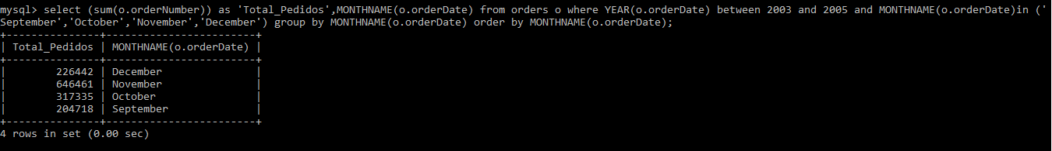

1. select e.lastName,sum(o.orderNumber) from employees e inner join customers c on e.employeeNumber=c.salesRepEmployeeNumber inner join orders o on c.customerNumber=o.customerNumber;

SELECT E.LASTNAME,COUNT(*) FROM CUSTOMERS C INNER JOIN EMPLOYEES E ON C.SALESREPEMPLOYEENUMBER=E.EMPLOYEENUMBER INNER JOIN ORDERS O ON O.CUSTOMERNUMBER=C.CUSTOMERNUMBER GROUP BY E.LASTNAME HAVING COUNT(*)>= ALL(SELECT COUNT(*) FROM CUSTOMERS C INNER JOIN EMPLOYEES E ON C.SALESREPEMPLOYEENUMBER=E.EMPLOYEENUMBER INNER JOIN ORDERS O ON O.CUSTOMERNUMBER=C.CUSTOMERNUMBER GROUP BY E.LASTNAME);

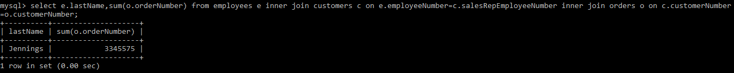

1. select (max(p.buyPrice)-min(p.buyPrice))*1000 as 'Diferencia' from products p;

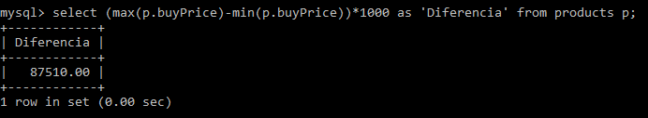

1. select e.firstName,e1.firstName from employees e inner j oin employees e1 on e.employeeNumber=e1.reportsTo;

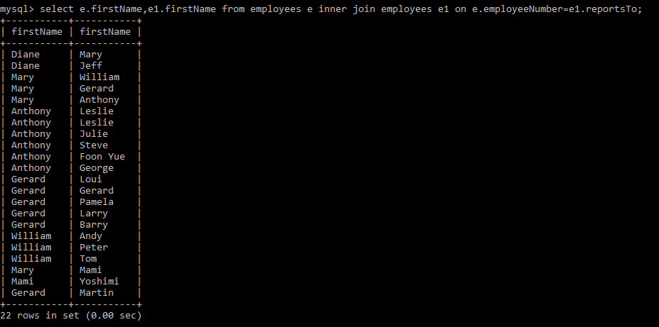

1. alter table employees add column hiredate date;

update employees set hiredate='2020-01-01' where hiredate is null;

